Jaden Martinez

2/22/2023

CS 470

Lab 4

1. Using the ln and ln -s commands, create hard and soft links.

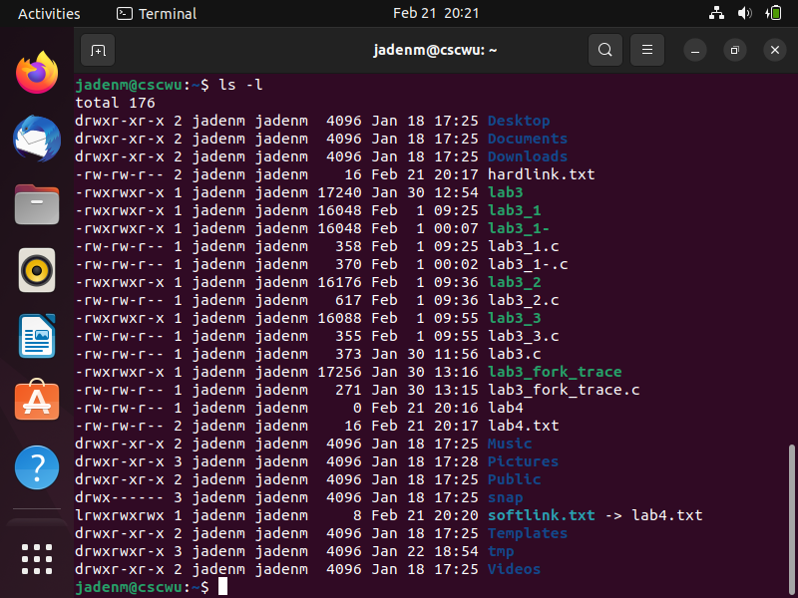

(soft link)

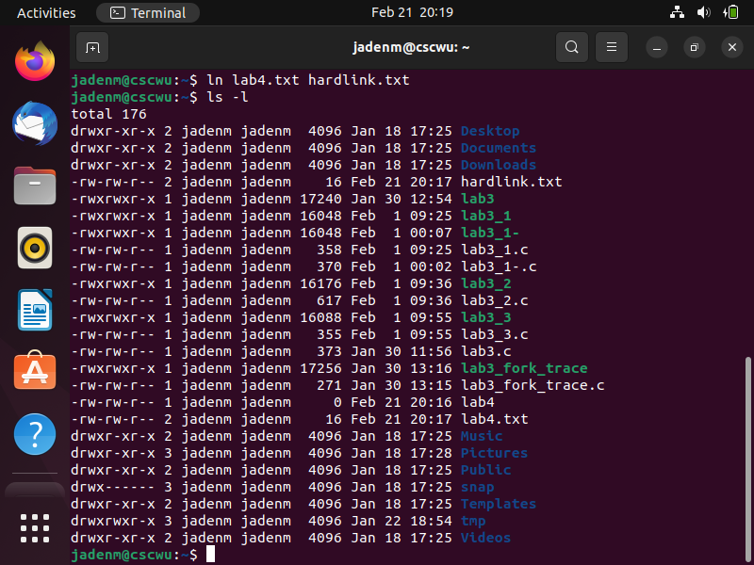

(hard link)

2. Create a multithreaded program that computes different statistical values for

a set of numbers. When given a series of numbers on the command line, this

application will start two independent worker threads. One thread will

compute the greatest value, and the next will compute the minimum value.

Assume your program is given a list of integers. (The array of numbers must

be provided as a parameter to the threads, and the thread must return the

calculated value to the main thread.)

2 20 25 5 70 90 98

The following will be printed in the main thread:

The min is 2.

The max is 98.

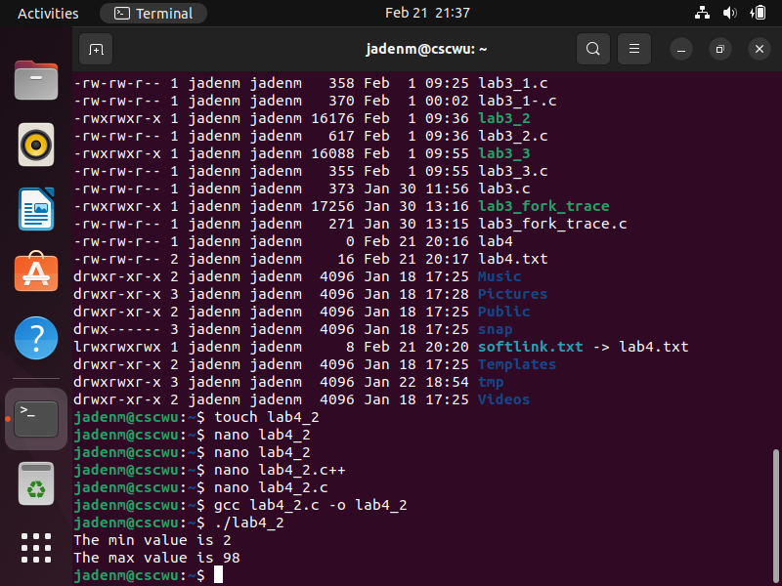

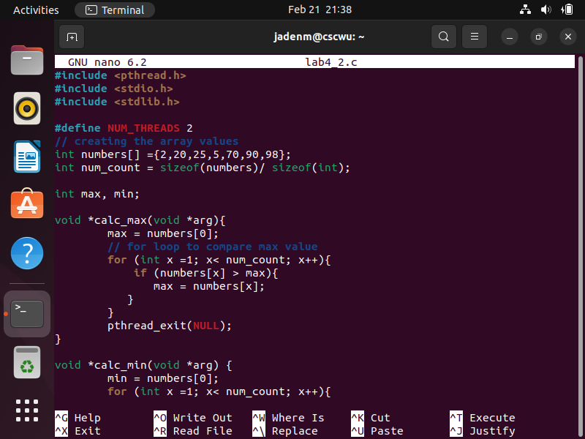

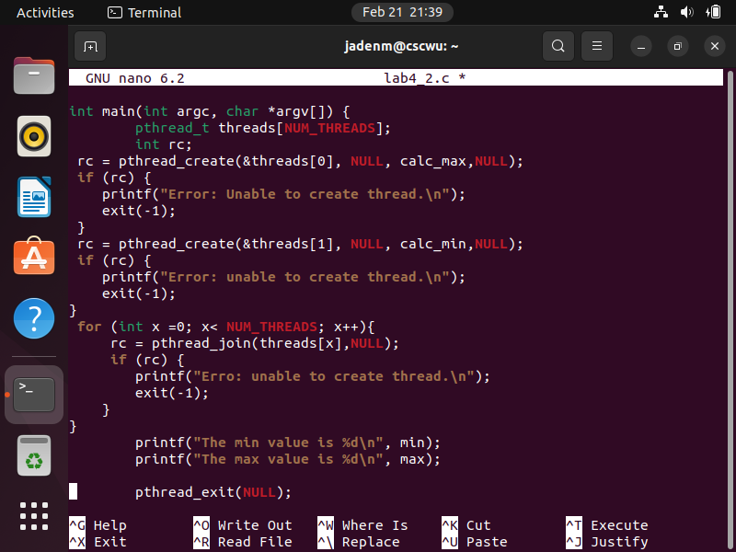

The code below creates a variable named numbers and its type array. I created a Calc_max method that assigns the max variable to the first index of numbers. This method code is based on For loop and If statement.Calc_max checks the first index with other index values If the other index is larger than the first index. The index value replaces the max variable. The Calc_min method is similar to the other method, but check to see the smallest value. It assigns the min to the first index of the number array. The min checks to see if any other index value is smaller than the current min. The smaller index value replaces the current min value. The Main method is used to create the threads for Calc_min and Calc_max. The threads join together after creating the thread. Then it prints the max value and min value of the numbers array.

3. Write a C program that opens the file "outputLab4.txt" for writing and

appends the phrase "This is a test for opening, writing, and closing a file!"

(code is below)

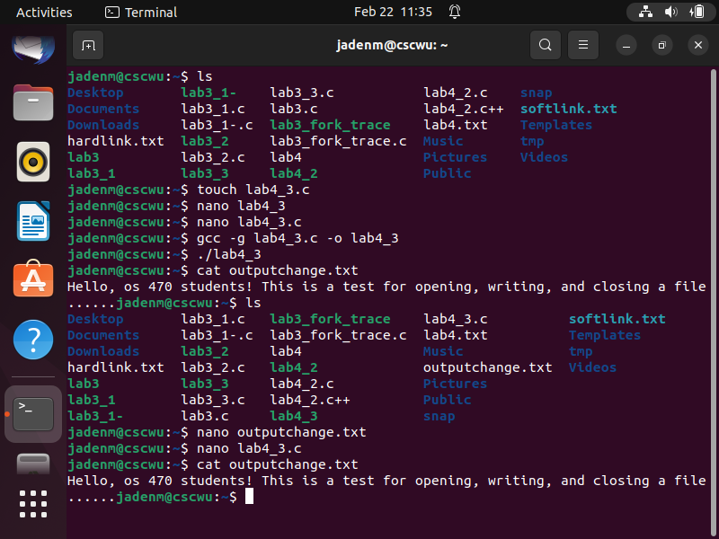 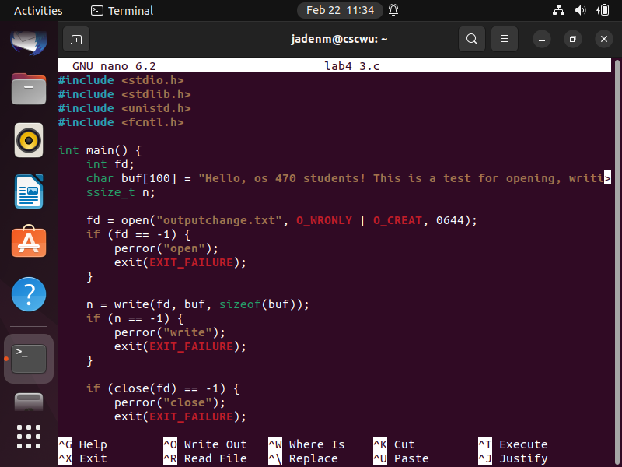

The code above is used to read, write, and close a file. I created an fd variable to be used to open the file. The fd is equal to the open function. The open function contains the document it wants to open ("outputchange.txt"). Also, it has the flags O_WRONLY and O_CREAT. Those flags assign write-only and create the file if it does not exist. Open at the end has numbers that indicate the permission of the document. The code calls the write function and assigns it to the n variable. The (Write) function writes the string and size value from buf[100] to the outputchange file. The code also checks if there is any error from the open, write, and close functions. If any of the functions contains an error, it prints an error code and exits the program.

4. Write a program for matrix addition, subtraction and multiplication using

Multithreading.

I had no time